1. Agenda:
   1. How to write distributed microservices?
   2. How to implement business logic that spans across multiple distributed microserivces  
      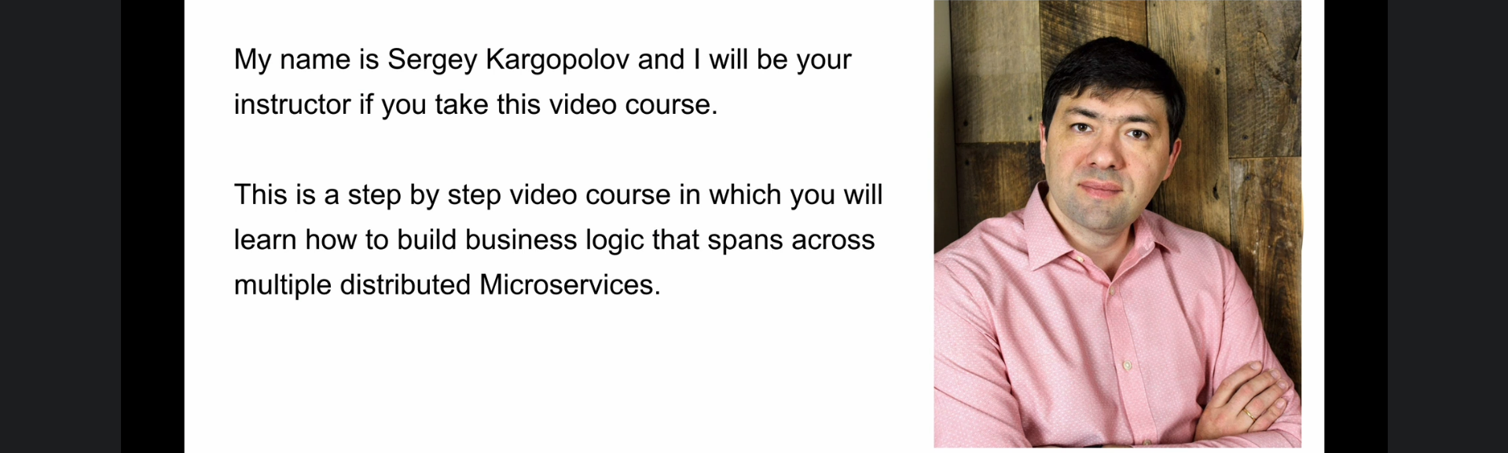
   3. 
   4. 